| A2  Group 02  Abdalrahman Afifi  Hunter Lavender  Travis Mueller  Zachary Wildasin |
| --- |

# GUI Diagram

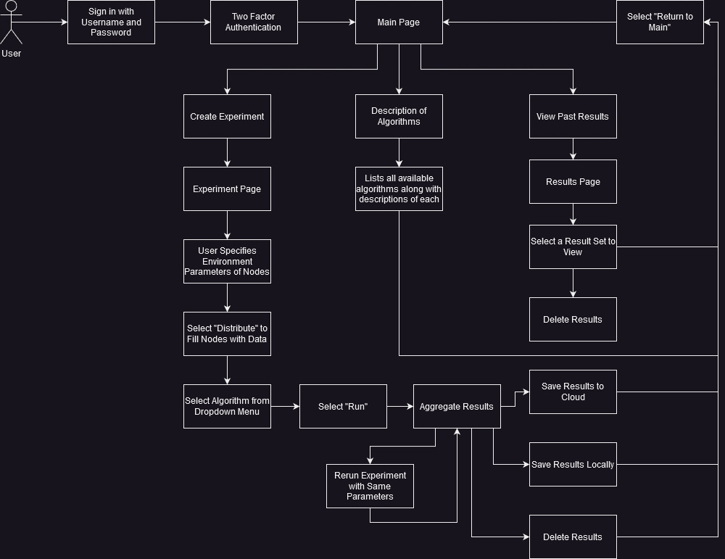

This is the frontend diagram of the PICARD and how it will operate.

# ER Diagram

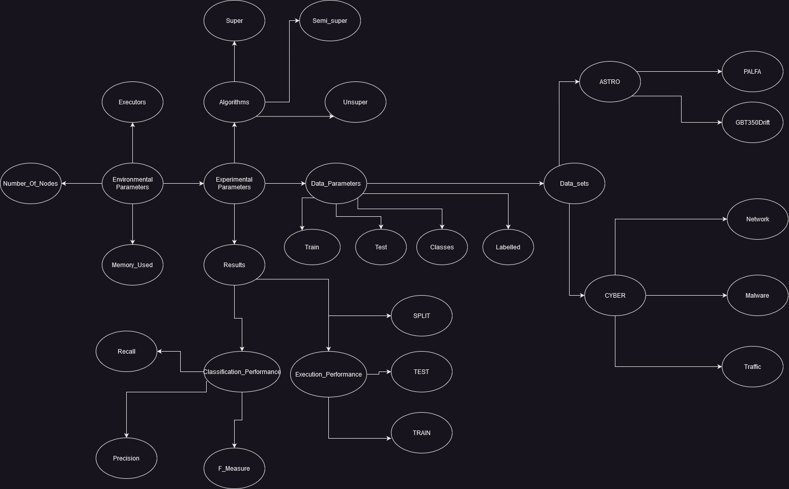

This is a diagram explaining the backend in the PICARD

# RM Schema

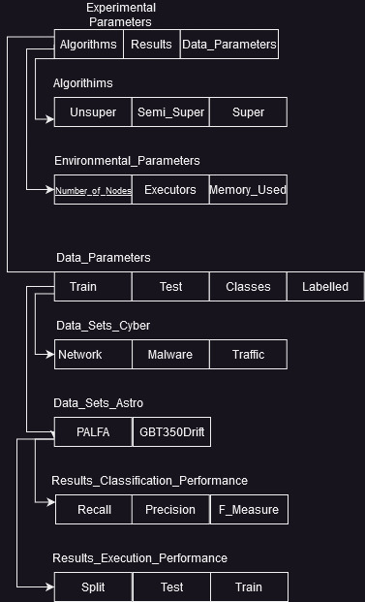

This the RM schema for PICARD which shows how the database will be built

# 

# 

# Member Contribution Table

Class: CSEE480 C01

Group Number: 02

Assignment Name: A2

| Member Name | Meetings attended | Meetings missed | Contribution | Stuff done by member |
| --- | --- | --- | --- | --- |
| Abdalrahman Afifi | 2 | 0 | 100 | ER Diagram, RM Schema, edits |
| Hunter Lavender | 2 | 0 | 100 | ER Diagram, RM Schema |
| Travis Mueller | 2 | 0 | 100 | Front end Diagram |
| Zachary Wildasin | 2 | 0 | 100 | Front end Diagram |